Question 1

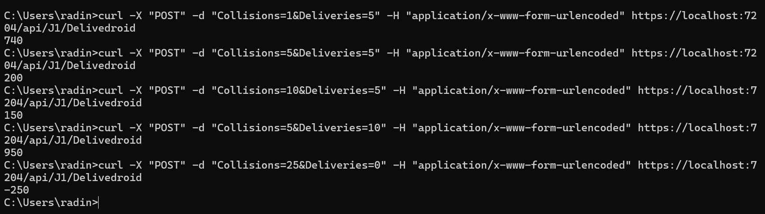

Question 2

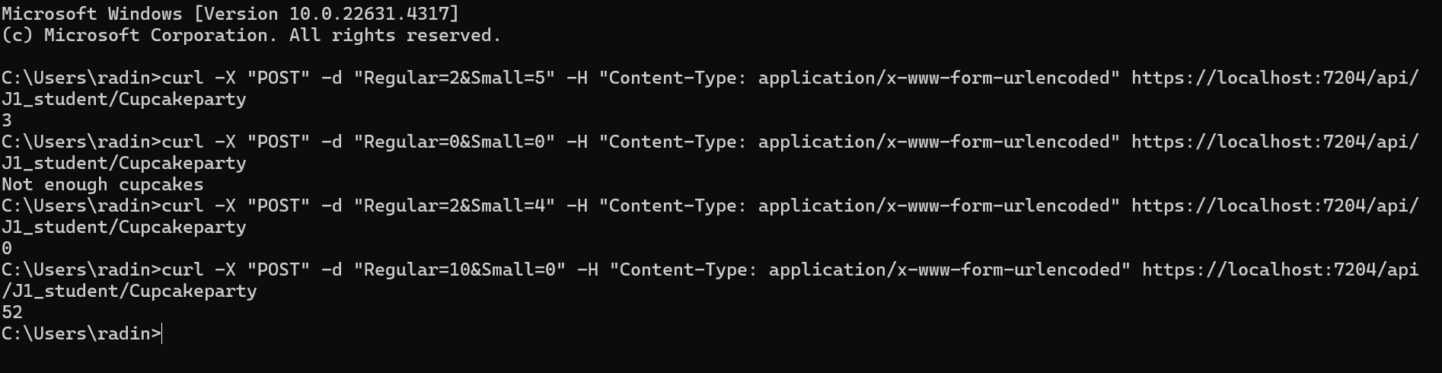

Question 3

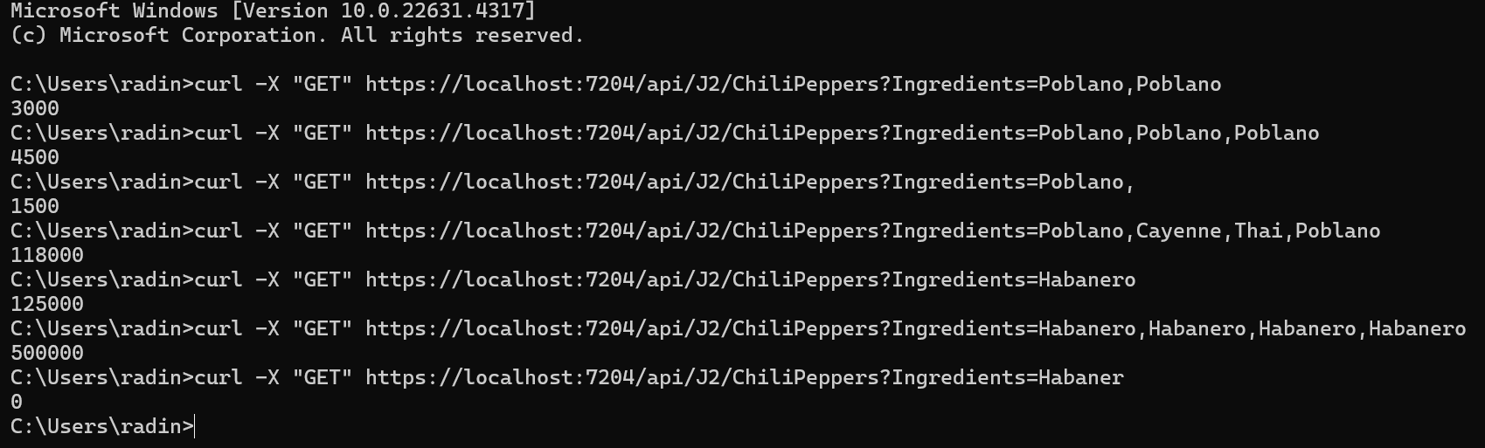

Question 4

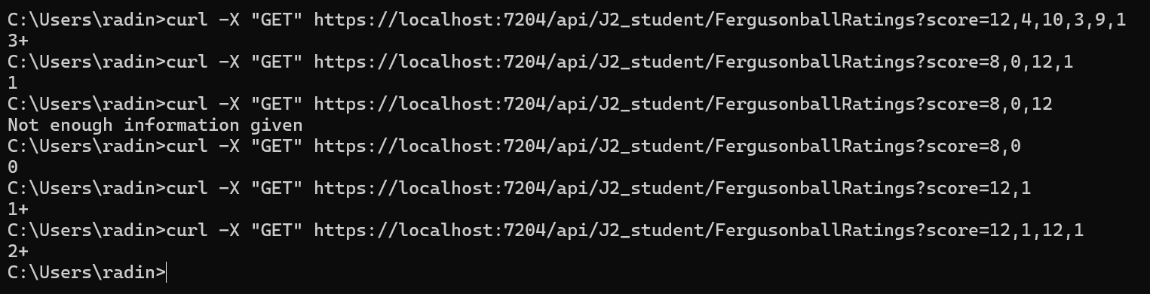

Question 5

